
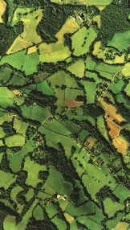
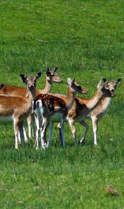
Deer Stalking Licence Agreement
Template

- Identification of the parties
1a. An Agreement between:

{Hereinafter referred to as the Landowner}

1b. And:

{Hereinafter referred to as the Deer stalker(s)}

1c. Allowing the deer stalker(s) permission to use licensed firearms of a deer- legal calibre for the stalking and culling of deer on the landholding given below, in accordance with; Deer Act (1991) until such a time as it is deemed appropriate to withdraw that permission.
Either party may withdraw from this agreement in writing at any time with immediate effect.
Address of land holding:

- Agreement outline
- Deer stalking activity must follow the aims and objectives of overall land management.
- Deer stalking activity will be confined to the area(s) defined by the Landowner or other authorised persons and indicated on an attached map.
- The Deer stalker(s) will respect the landholding and any livestock and or crops thereon and will behave in a safe and responsible manner at all times.
- The Deer stalker(s) must hold an appropriate deer stalking qualification and public liability insurance.
- The Deer stalkers(s) will retain all deer carcasses unless agreed otherwise.
- The Deer stalker(s) will bear responsibility for prior notification of stalking activities to the Landowner and or other appropriate persons.
2a. Notification method:
www.highweald.org
- Deer stalker information
Deer stalker name | Telephone no. | Insurance information | Trained hunter no.

- Relevant signatures
Signed: |  | (Landowner) | Date:

Signed: |  | (Deer stalker) | Date:

Signed: |  | (Deer stalker) | Date:

Signed: |  | (Deer stalker) | Date:

Signed: |  | (Deer stalker) | Date:

www.highweald.org

Note: Two or more copies of this document must be distributed amongst all of the agreeing parties

