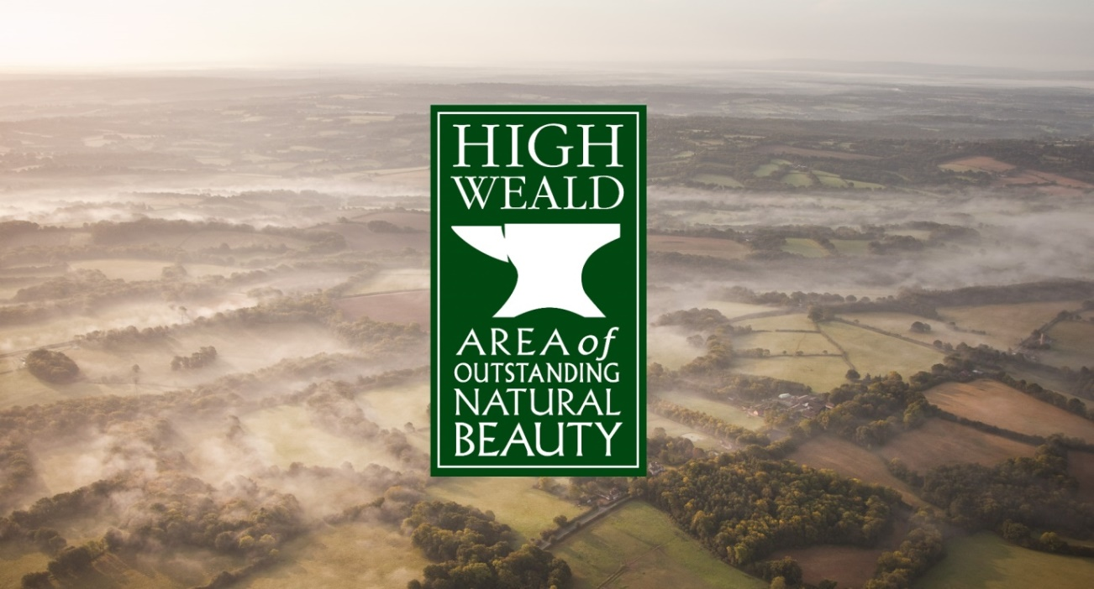
High Weald Area of Outstanding Natural Beauty
Consultation on Draft Management Plan 2019-2024

The High Weald AONB Partnership is currently collecting feedback on the Draft Management Plan 2019-2024 and its supporting reports.
If you haven’t already done so, please download a copy of the draft Plan here. We would particularly welcome your views on the sections of the plan we have highlighted in green:
- AONB Vision and the Statement of Significance - do you agree?
- The area’s character - have we identified what makes the area distinctive and special to you?
- What needs to be done - have we identified the activities that would most benefit the landscape and its communities over the coming five years?
Please fill in the form, save it and email it to plancomments@highweald.org by 25 July 2018. Alternatively, you can print it out and send by post to High Weald AONB Partnership, Woodland Enterprise Centre, Hastings Road, Flimwell, East Sussex, TN5 7PR.

YOUR DETAILS

First Name Click here to type
Surname Click here to type
Organisation (if applicable) Click here to type
Email Address Click here to type

CONSULTATION QUESTIONS
Do you agree with the AONB Vision? (please tick one)
☐ Strongly Agree
☐ Agree
☐ Disagree
☐ Strongly disagree
☐ Don’t know

Do you agree with the Statement of Significance? (please tick one)
☐ Strongly Agree
☐ Agree
☐ Disagree
☐ Strongly disagree
☐ Don’t know

GEOLOGY, LANDFORM, WATER SYSTEMS & CLIMATE
Do you have any comments on the AONB Character for Geology, landform, water systems and climate?
Input your answer here – the box will expand as you type

Do you have any comments on the Aims & Actions for Geology, landform, water systems and climate? (please state which objective you are commenting on)
Input your answer here – the box will expand as you type

What additional Aims & Actions could communities and individuals carry out to help conserve the AONB? Please looks at the examples in the draft Plan and include any suggestions below (please state which objective you are commenting on)
Input your answer here – the box will expand as you type

SETTLEMENT
Do you have any comments on the AONB Character for Settlement?

Input your answer here – the box will expand as you type

Do you have any comments on the Aims & Actions for Settlement? (please state which objective you are commenting on)
Input your answer here – the box will expand as you type

What additional Aims & Actions could communities and individuals carry out to help conserve the AONB? Please looks at the examples in the draft Plan and include any suggestions below (please state which objective you are commenting on)
Input your answer here – the box will expand as you type

ROUTEWAYS
Do you have any comments on the AONB Character for Routeways?

Input your answer here – the box will expand as you type

Do you have any comments on the Aims & Actions for Routeways? (please state which objective you are commenting on)
Input your answer here – the box will expand as you type

What additional Aims & Actions could communities and individuals carry out to help conserve the AONB? Please looks at the examples in the draft Plan and include any suggestions below (please state which objective you are commenting on)
Input your answer here – the box will expand as you type

WOODLANDS
Do you have any comments on the AONB Character for Woodlands?

Input your answer here – the box will expand as you type

Do you have any comments on the Aims & Actions for Woodlands? (please state which objective you are commenting on)
Input your answer here – the box will expand as you type

What additional Aims & Actions could communities and individuals carry out to help conserve the AONB? Please looks at the examples in the draft Plan and include any suggestions below (please state which objective you are commenting on)
Input your answer here – the box will expand as you type

FIELD AND HEATH
Do you have any comments on the AONB Character for Field and Heath?

Input your answer here – the box will expand as you type

Do you have any comments on the Aims & Actions for Field and Heath? (please state which objective you are commenting on)
Input your answer here – the box will expand as you type

What additional Aims & Actions could communities and individuals carry out to help conserve the AONB? Please looks at the examples in the draft Plan and include any suggestions below (please state which objective you are commenting on)
Input your answer here – the box will expand as you type

LAND BASED ECONOMY AND RELATED RURAL LIFE
Do you have any comments on the AONB Character for Land based economy and related rural life?

Input your answer here – the box will expand as you type

Do you have any comments on the Aims & Actions for Land based economy and related rural life? (please state which objective you are commenting on)
Input your answer here – the box will expand as you type

What additional Aims & Actions could communities and individuals carry out to help conserve the AONB? Please looks at the examples in the draft Plan and include any suggestions below (please state which objective you are commenting on)
Input your answer here – the box will expand as you type

OTHER QUALITIES AND FEATURES
Do you have any comments on the AONB Character for Other qualities and features?

Input your answer here – the box will expand as you type

Do you have any comments on the Aims & Actions for Other qualities and features? (please state which objective you are commenting on)
Input your answer here – the box will expand as you type

What additional Aims & Actions could communities and individuals carry out to help conserve the AONB? Please looks at the examples in the draft Plan and include any suggestions below (please state which objective you are commenting on)
Input your answer here – the box will expand as you type

OTHER COMMENTS
If you have any other comments on the Draft AONB Management Plan, please include them here.
Input your answer here – the box will expand as you type

We are also seeking comment on the Management Plan’s supporting technical documents: the Strategic Environmental Assessment, the Habitats Regulations Assessment and the Equality Impact Assessment. If you would like to comment on these documents, they can be downloaded at www.highweald.org/public-consultation-2018. Please include your thoughts in the box below.

Input your answer here – the box will expand as you type

END OF CONSULTATION, THANK YOU FOR YOUR COMMENTS.
Please save this form and email it to plancomments@highweald.org by 25 July 2018. Alternatively, you can print it out and send by post to High Weald AONB Partnership, Woodland Enterprise Centre, Hastings Road, Flimwell, East Sussex, TN5 7PR.

